
Workflow: Importing and Changing Zoning Regulations
Version: 1.0 beta
Date: November 30, 2012

Introduction
This workflow explains how to set up and use a Legal Environment (Zoning and land Ownership) in a 3D cities database. The primary steps are:
- Defining the regulations
- Importing regulations, applying them to parcels and changing them
- Exporting to CityEngine
- Creating a Web Scene

Requirements to execute this workflow
Software:
- ArcGIS 10.1 SP1
  - Data Interoperability extension (or FME 2012)
- CityEngine 2012.1
- Microsoft Excel or OpenOffice/LibreOffice Calc
Data:
- 3D Urban Information Model Database (please refer to Workflow 1 for set-up information)
- Zoning District Polygons
- Land or Tax Parcel Polygons
- Street centerlines or curbs

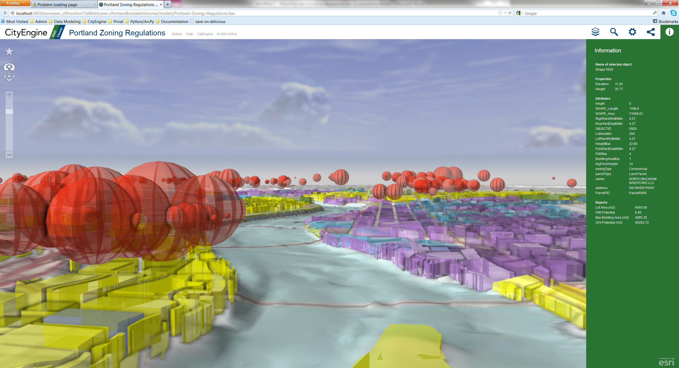
Visualizing your zoning regulations, development potential and base 3d city in the Web Viewer

Part 1: Defining the Regulations
Most cities and communities have a written document containing all the regulations that are applied in planning. These include regulations on the buildable volume (layout and mass), on form, style and allowed use of the buildings, and on functional criteria as well in some cases. These regulations are often described in a text-only form and need to be extracted and formalized to be useful in setting up a 3D zoning map as shown on the first page of this document. This section explains how to do this extraction.
The 3DUIM Toolboxes, including the Legal Environment and Portland Example tools are needed for this workflow and need to be installed first if not already done in workflow 1:
- Copy the content of the folder “toolboxes” from the unzipped download package to the My Toolboxes location.
  - Under Windows 7, this location is
“C:\Users\User\AppData\Roaming\ESRI\Desktop10.1\ArcToolbox\My Toolboxes”.
  - Under Windows XP, the location is
“C:\Documents and Settings\User\Application Data\ESRI\Desktop10.1\ArcToolbox\My Toolboxes”
  - Sometimes, the location has been customized. Find out more about this online.
- Restart ArcCatalog.
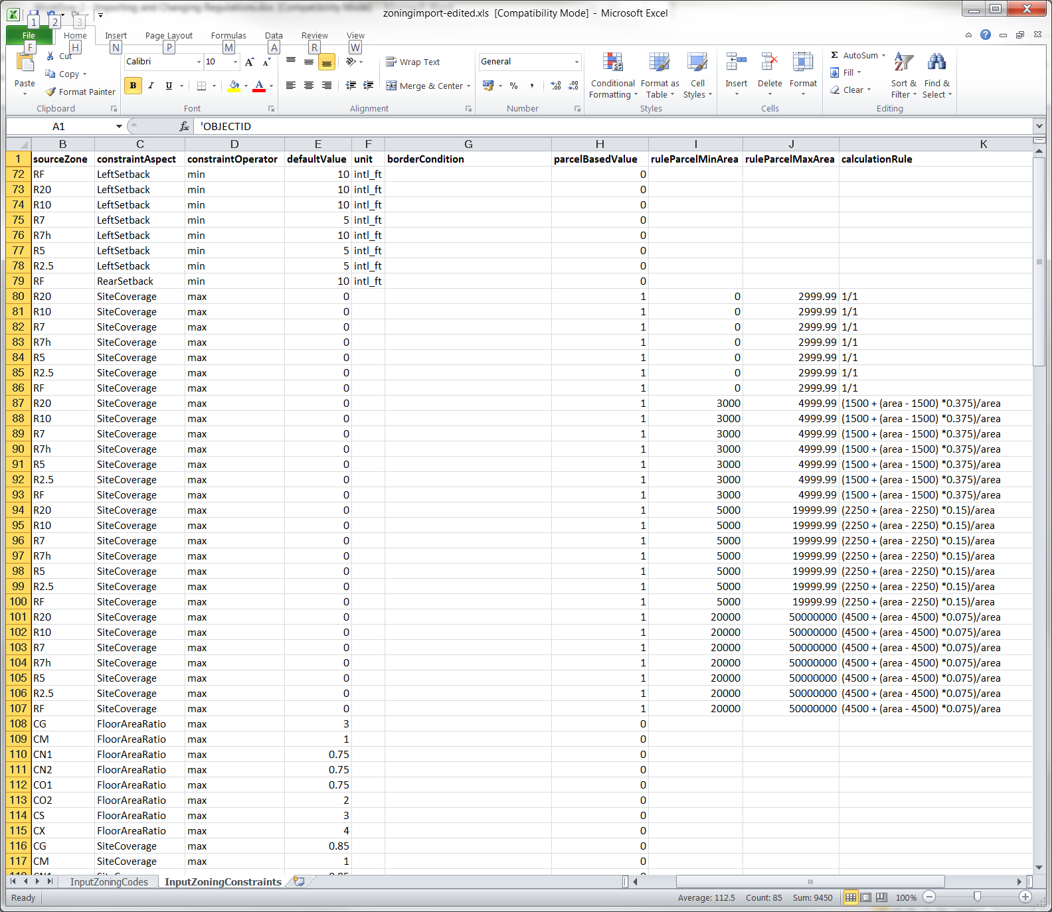
If you find that ArcCatalog doesn’t start up after copying in the toolboxes, delete the file called ArcToolbox.dat in the ArcToolbox folder.
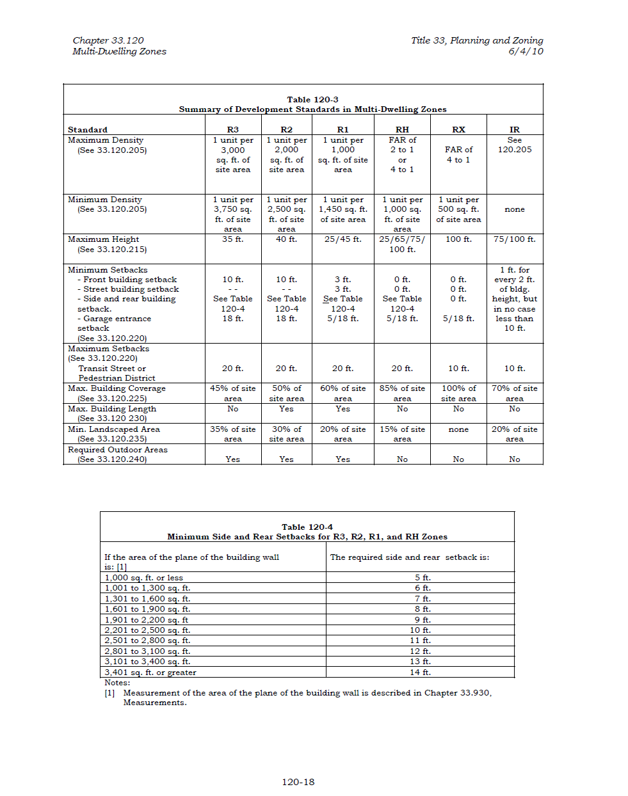
Transforming legal texts and tables to computer-tractable regulations
In the 3D urban information model, you can use regulations that relate to the setback, the shape of the building volume and a number of other planning aspects. These aspects need to be documented in a spreadsheet table using the following steps:
- Open Excel/Calc and load the document /Application/Configuration/zoning-regulations-portland.xls and go to the InputZoningCodes sheet. In this sheet, you’ll map your local zoning classes to the values used by the 3D urban information model. This step is necessary to insure that the tools and procedural rules delivered with the 3DUIM have a common base to work on. Have a look at the example entries for Portland, then add your own (and removing all of the examples that don’t fit your needs).
Using the InputZoningCodes sheet, fill in the following fields for each of your zoning codes:
  - sourceZone: The code you use in your zoning regulations to identify a specific zone type.
  - targetZone: One of Open Space, Industry, Residential Single, Residential Farm, Residential Multi, Commercial and Employment.
  - targetDensity: Optional, unitless value indicating relative density of the zone in the 0...1 range.
  - targetOverlay: Enter 1 if this zone represents an overlay zone. Overlay zones are used to indicate additional permitted uses.
  - targetVerticalExtentMin: Optional value indicating a vertical extent limit on which this code is effective. The value is relative to the surface used for the urban model, such as DTM.
  - targetVerticalExtentMax: Optional value indicating a vertical extent limit on which this code is effective. The value is relative to the surface used for the urban model, such as DTM.
  - targetVerticalExtentUnit: Required if either targetVerticalExtentMin and targetVerticalExtentMax is set. Indicates the unit of measurement of targetVerticalExtentMin and targetVerticalExtentMax is. Allowed values are m, intl_ft, and level.
- Next, go to the InputZoningRegulations sheet. Again have a look at the example entries for Portland, then add your own (and removing all of the examples that don’t fit your needs). This is where you enter the actual regulations, using these fields:
  - sourceZone: The Zoning identification used in your code, such as RH, R2.5 or IND. Has to match the code used in InputZoningCodes and the codes in your ZoningDistricts source data.
  - constraintAspect: The aspect that you want to regulate, such as FAR, site coverage, (front/left/right/rear) setback, maximum height, or required skyview angle.
  - constraintOperator: The operator used to indicate whether you are setting a minimum, maximum or exact (equal) value.
  - defaultValue: The numeric value of the regulation, e.g. 14 to indicate a minimum setback of 14 feet.
  - unit: A string identifier for the unit that the defaultValue is in. Right now, international feet (intl_ft) and meters (m) are supported.
  - borderCondition: Any regulation can be dependent on a certain condition being met. This condition can be e.g. that a different setback is needed when a residential parcel sits next to a major transport corridor or next to industry.
  - parcelBasedValue: Set to “1” if the value of the regulation needs to be calculated using a mathematical expression based on the attribute values of a feature, instead of using a constant value.
  - ruleParcelMinArea: The minimum area a parcel has to have for this rule to take into effect.
  - ruleParcelMaxArea: The maximum area a parcel has to have for this rule to take into effect.
  - calculationRule: The mathematical expression used to calculate the per-Parcel value. In this expression, you can use all common operators (+, -, *, /) and any attribute name that the parcel data will have.

Have a look at the following three examples to see what kind of regulations can be set up:

Example for a simple regulation defining a minimum frontside setback of 15 feet:
- Add the zoning code for which the regulation is to be in effect. The ZoningDistrict polygons you will later import need to use the same codes.
- Set the constraintAspect to FrontSetback.
- Set the constraintOperator to min.
- Set the defaultValue to 15.
- Set the unit to intl_ft.

Example for a regulation with a border expression defining a maximum streetside setback of 2 meters:
- Add the zoning code as above.
- Set the constraintAspect to Setback. Setback is a shorthand value combining the FrontSetback, RearSetback and LeftSetback codes.
- Set the constraintOperator to max.
- Set the defaultValue to 1.
- Set the unit to m.
- Set borderCondition to “TransportNetworkElement/Road”. This code indicates that for each segment of a Parcels’ border which is next to a feature of class TransportNetworkElement with the type attribute set to “Road”, this regulation is to take effect.
Example for a regulation with a parcel-based expression, using the parcel area to calculate allowed site coverage:
- Add the zoning code as above.
- Set the constraintAspect to SiteCoverage.
- Set the constraintOperator to max.
- Set the defaultValue to 0.
- Leave the unit and borderCondition empty.
- Set parcelBasedValue to 1.
- Set ruleParcelMinArea to 250 and ruleParcelMaxArea to 500. The unit is n², with n being the horizontal unit of your spatial reference system, e.g. meters, international feet or degrees.
- Set calculationRule to ((area – 100) * 0.75)/area. This equals site coverage of 0.75 for the area of the parcel exceeding 100 n². When this expression is evaluated, actual per-parcel values will thus be 0.45 and 0.6.
Proceed to set up your regulations using Excel’s functionality to copy, paste and adjust rule blocks. Creating the 150+ regulations in the Portland example, took approximately 4 hours.

Part 2: Import Zoning and Regulations into your 3D City database
After going through the initial setup of your regulations, you are now ready to set up the legal environment (land ownership and zoning regulations) of your 3DUIM database. This section explains which tools to use and how to update the regulations later. The workflow is explained using the Portland example data and the associated Toolbox called “3DUIM Portland Examples”. You will need to customize aspects of the ETL tools to use these with your own data.

Initial Importing
The initial import will populate the 3DUIM database with your source zoning data as ZoningDistricts, and will attach Regulation objects to them. In the default setup, each ZoningDistrict gets its own copies of the Regulation objects, so that you can individually edit them to capture exceptions.
In ArcCatalog, first import the Parcels if not already done in Workflow 1.
- Open the “3DUIM Portland Examples” toolbox and double-click on the “Import Parcels” tool. This dialog opens:
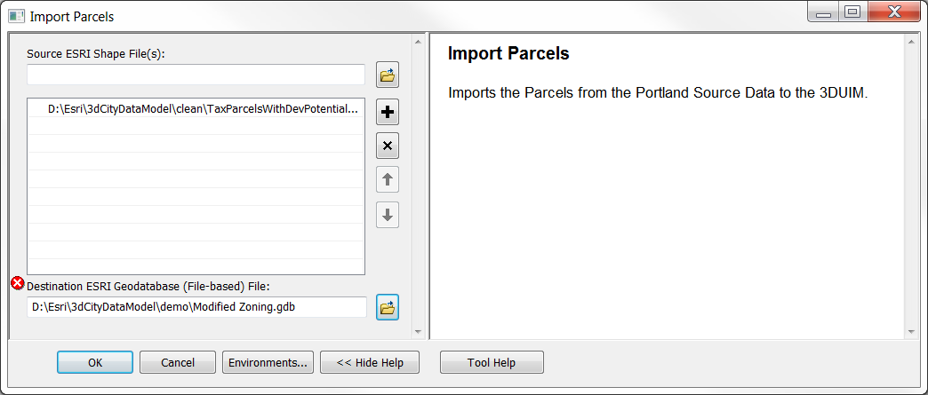
- Pick the correct ESRI shapefile with the parcels located in /MapsandGeodatabase/PortlandExample/Parcels.shp, as well as the Destination File Geodatabase that you created in Workflow 1, Part 1. Then, press “OK” and let the tool run.
Then, import the zoning districts and regulations. In this step, ZoningDistrict Polygon features are inserted, Regulation objects are added and linked to ZoningDistricts, and parcel-based values as set in the calculationRules you used in Part 1 will be evaluated. The resulting Regulations objects will be related to the Parcels.

- Open the “3DUIM Portland Examples” toolbox, and double-click on the “Import Source Zoning and Generate Regulations” tool.
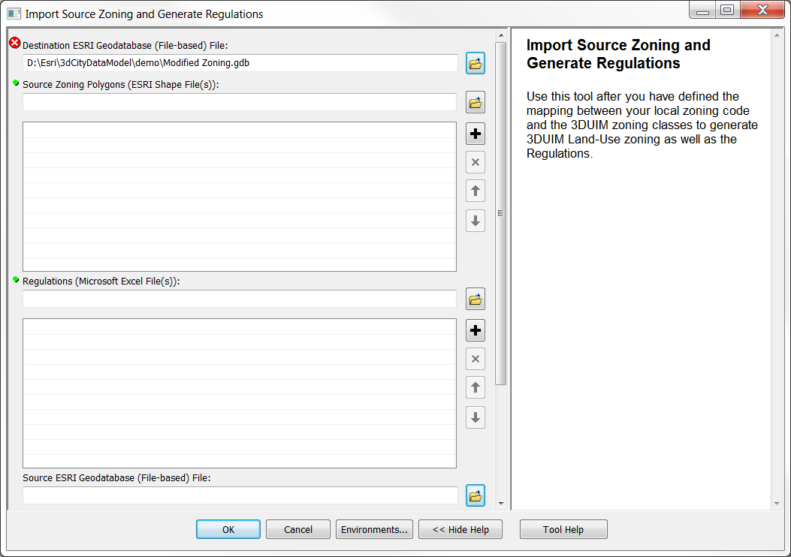
- Pick the Source File geodatabase (parameter at the bottom), as well as the Destination File Geodatabase that you created in Part 1. Both parameters should be se to the same geodatabase.
Furthermore, you need to add the file with your zoning polygons to the parameter called “Source Zoning Polygons (ESRI Shape file(s))”. Also, you must make sure that the parameter “Regulations (Microsoft Excel File(s))” is set to the location of the zoning-regulations-portland.xls that was created in Part 1. Then, press “OK” and let the tool run.
The third step in the setup of the 3DUIM Legal Environment is the calculation of the Neighborhood of each Parcel. This Neighborhood is important for regulations that have a border condition defined:
- Open the “3DUIM Data Management” toolbox, and double-click on the “Calculate Parcel Neighborhood with Streets” tool. This dialog opens:
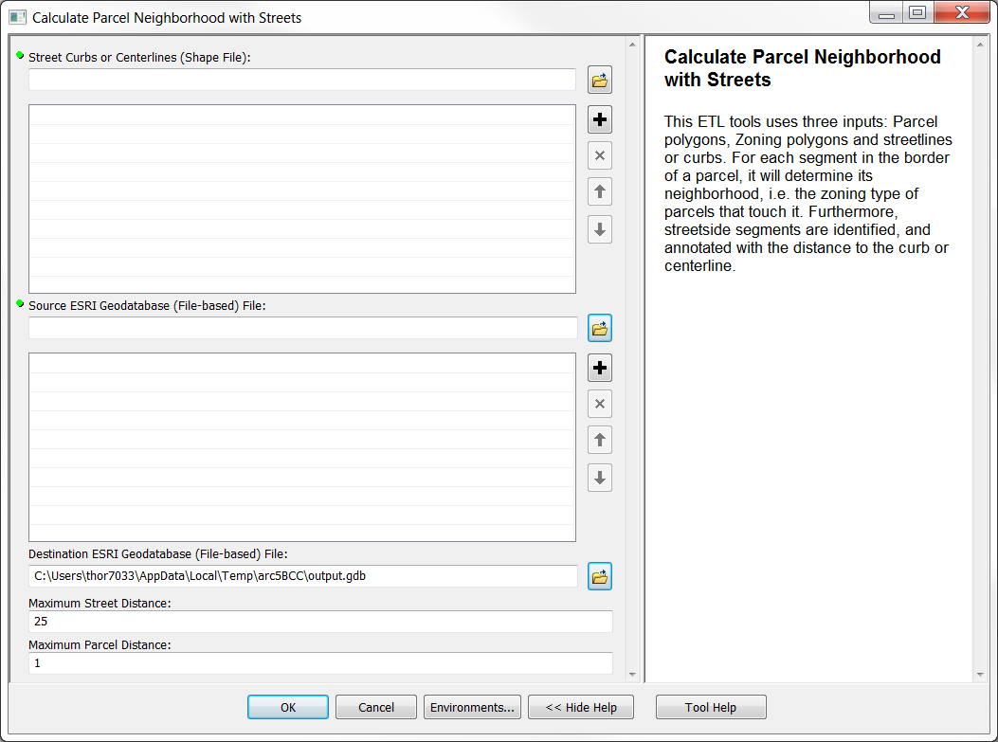
- Pick the Source File geodatabase (parameter at the bottom), as well as the Destination File Geodatabase that you created in Part 1. Both parameters should be set to the same geodatabase. Add a Shape file for the street centerlines or curbs (the Portland example data can be found in /MapsandGeodatabase/PortlandExample/Curbs.shp). You might need to adjust the maximum search distance for neighboring streets and parcels depending on the horizontal unit your spatial reference system needs. In the Portland example, we’re using international feet and street curbs, for which the values provided work well.
Then, press “OK” and let the tool run.
You now have a complete 3DUIM legal environment in a single file geodatabase. For all of the tools, if there are derivations in the source shapefiles or databases (e.g. because you use a different shape file schema for your Parcels), the ETL tools will not run right away or there may be errors in the transformation process. You should thus verify the results of the data import, e.g. by reviewing the data in ArcMap.

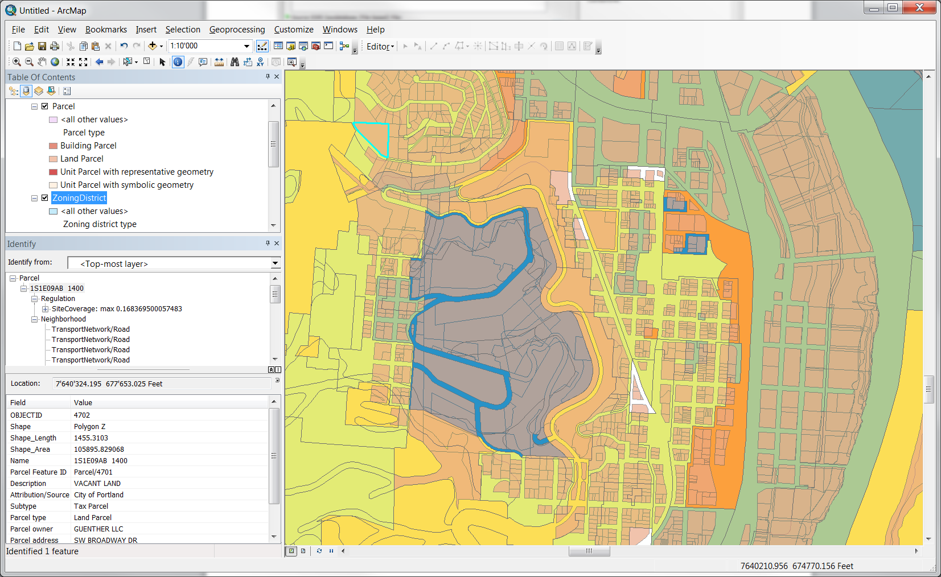
ArcMap with a complete 3DUIM Legal Environment after going through Parts 1 and 2. Note that the selected Parcel has both a Regulation on site coverage and neighborhood information attached.

Editing Regulations
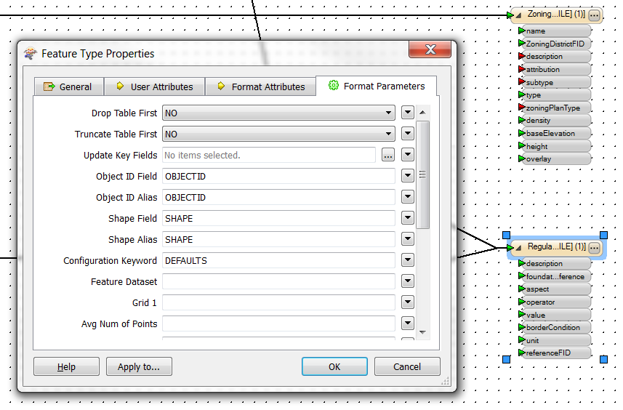
Over time, you will want to assess the impact of changed regulations on aspects such as development potential and visual impression. To edit your zoning regulations as a whole, proceed as follows:
- Update the Regulations spreadsheet as desired, adding new regulations or editing existing ones.
- Invoke the tool “Import Source Zoning and Generate Regulations” from the Portland Examples toolbox.
- You can either update an existing file geodatabase or create a new one with the new regulations:
  - To update, first delete any regulations from your File GDB that are now obsolete. This can be done in ArcGIS in the table view. Then, edit the “Import Source Zoning and Generate Regulations” tool by right-clicking on it in the catalog tree and selecting “Edit…”. Go to the Writer for the feature class “Regulation”, and change “Truncate Table First” to “NO”. Save the edited ETL tool, leave the FME workbench and invoke the tool as usual.
  - To create a new File GDB with updated regulations, just pick a different File GDB as target than the source one. If you want this new GDB to be complete, e.g. have all feature classes and domains defined, you should use one which has had the 3duim schema applied (see Workflow 1/Part1).
- If you haven’t modified the ZoningDistrict geometries or the Parcel geometries, the Parcel Neighborhood doesn’t need to be recreated.
You can always edit individual regulations attached to Parcels and ZoningDistricts. The details of this are described in Workflow 3.

Part 3: Exporting to CityEngine 2012.1
Your regulations are at this stage only 2D parcels and zoning districts. To turn them into 3D building envelopes, representative buildings and to generate reports on these, we will export the parcels and associated information to CityEngine.
To run the Portland example, there is a complete CityEngine Project including DEM, topographic basemap, orthoimagery, Parcel shapes, rules and scripts available from the download package under /Application/CityEngine/PortlandBuildableVolumes. To work with your own data, proceed as follows.
First, we need to join in the information that sits in the tables related to Parcels – i.e. the Neighborhood, the Regulations themselves and the zoning type that is part of the ZoningDistrict features.
- Open the “3DUIM CityEngine Tools” toolbox, and double-click on the “CE Export: Merge Regulations into Parcels”. This dialog opens:
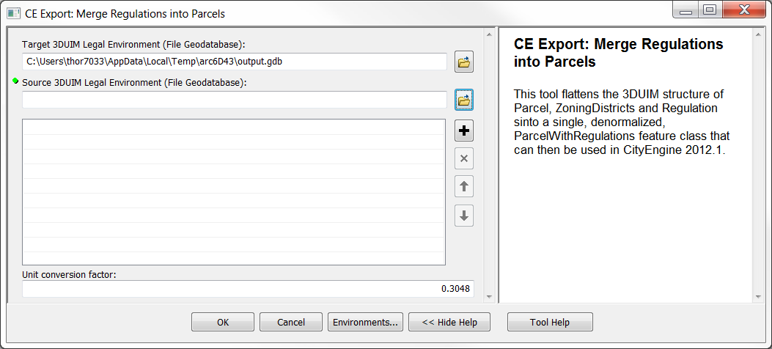
- Chose a new and empty File Geodatabase as the “Target 3DUIM Legal Environment”. Then pick your Legal Environment File GDB created in Part 2 as the Source 3DUIM database.
- Note that CityEngine can only use meters in rules, so you also have to set the Unit Conversion Factor appropriately! In the example, the regulations were entered in international feet, so a unit conversion of 0.3048 needs to be applied. If your data is already in meters, change this to “1.0”. Click OK and let the tool run.
- If you have neighborhood information created in part 2, open the “3DUIM CityEngine Tools” toolbox, and double-click on the “CE Export: Merge Neighborhood into Parcels” tool. The ETL tool has these parameters:
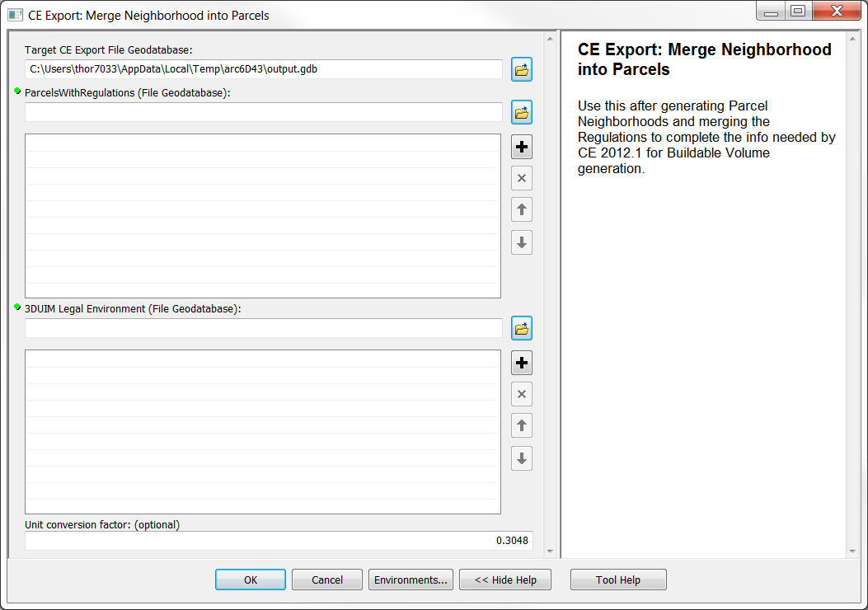
- For the ParcelsWithRegulations File Geodatabase and the Target CE Export File Geodatabase, pick the File GDB you have used in Step 2. Select the same Legal Environment File Geodatabase you used in step 2, and check whether the Unit Conversion Factor still applies. Click OK and let the tool run.
You now have a File GDB which contains the parcels from your 3duim database, with all related information folded in:
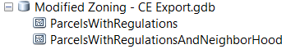
Next, start CityEngine 2012.1 and set up a new project:
- In CityEngine, go to File -> New…, and select the CityEngine project:
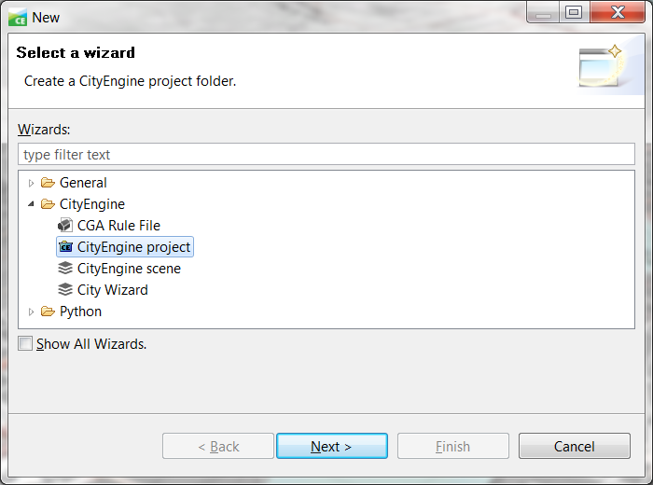
- Name the project and select a location where it should be stored. You should now close all other projects except this new one.
- In the new project, go to the folder “Scenes”, right-click on it and pick New…->CityEngine Scene. You can use any file name you want to. The new scene is automatically opened.
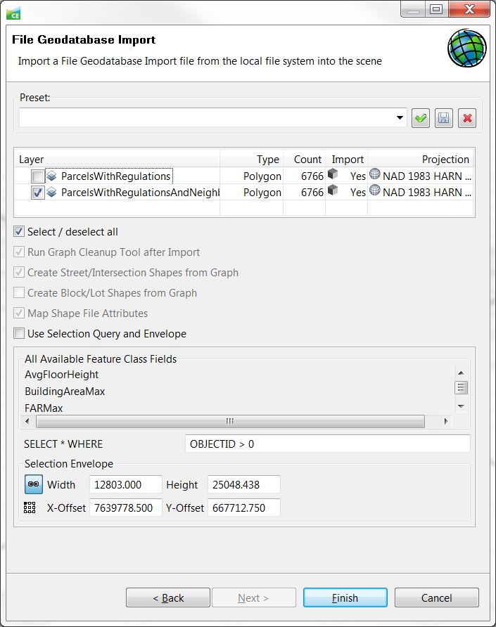
- Next, open your file browser (i.e. Explorer) and drag the File GDB with the CityEngine features on top of the “data” folder in the new project. In the Prompt, pick “Copy Files and Folders”.
- Right-click on the File GDB Folder, and pick Import…. Chose File GDB import, and you will see the dialogue shown right:
- Select only the ParcelsWithRegulationsAndNeighborhood if you generated them, otherwise pick the ParcelWithRegulations. Click on “Finish”.
- CityEngine will now import the parcels as initial shapes and will display them in the scene.
- To make use of the neighborhood information, you will now need to run a Python script. The script can be found in the download package under Application/CityEngine/PortlandBuildableVolumes/ scripts/RenameStreets.py.
Copy the script to the scripts folder of your new CE project, open it and execute it by pressing F9. The Parcels now have streetWidth attribute lists.
- Now you’re almost there – only the rule needs to be applied to the Shape in the scene. Pick the rule “Zoning Rules.cga” from /Application/CityEngine/ PortlandBuildableVolumes/rules, drop it into your project’s rule folder, and then select all shapes in your scene. Now, drag and drop the rule on the selected shapes, and watch the building envelopes being generated!

Part 4: Creating a Web Scene
The final step in publishing your Zoning Regulations as a 3D Web Map, which can be used to discuss and collaborate with citizens and decision makers, is creating a 3D Web Scene from your CityEngine project There is a tutorial on the generic process of doing so available here.
This section thus only explains the specific process used to bring your building envelopes out as a web scene. If you want to use the PortlandBuildableVolumes Example project, open the CE scene called Portland Buildable Volumes.cej.
- Select all shapes that you want to export.
- Remove any attributes that should become part of the exported web scene by clicking on them in the Shapes tab, in the section Object Attributes, and pressing “Del”. Also, make sure that all your layers have appropriate names. These can be edited after picking a layer in the Scene outline and editing the name in the text box in the upper right corner.
- Go to File -> Export Models…, and pick “CityEngine WebScene”. Enter the name for the web scene – this will be displayed in the title later. Then, click “Next” and this dialog is displayed:
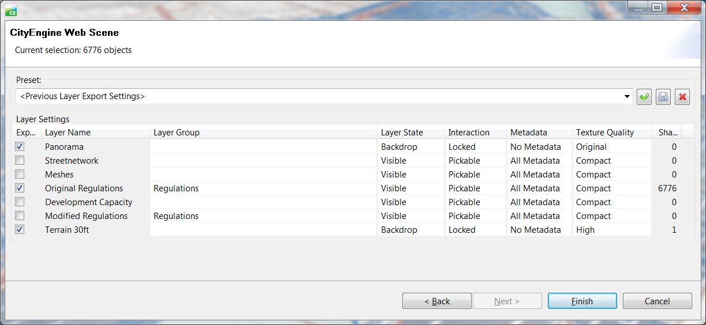
- Checking the boxes on the left-hand side decides about inclusion of the layer in the web scene. You can also add A Layer Group label to indicate layers that the user should be able to alternate between – only one layer of a group can be displayed at any time. Adapt the initial layer visibility by changing the Layer state, and make the core features pickable. For the Terrain, you should set the Texture Quality to High or Original. The other settings can be left as-is. Press “Finish” and let the exporter run!
- Right-click on the newly-created web scene file in the folder, pick “Open with - > 3D Web Scene Viewer” and enjoy the 3D buildable volumes in your browser!
Template: Importing and Changing Regulations
Version: 1.0 beta
Date: November 30, 2012

Release Notes
The November 30, 2012 release is the first release of the Importing and Changing Regulations workflow for ArcGIS 10.1.

New Functionality

N/A

Resolved Problems

N/A

Known Issues

N/A

Please refer to http://support.esri.com/en/knowledgebase/techarticles/detail/39256

